Name _ Rishabh Manchanda  
  
Employee ID:

109883998

Here are the key features introduced in Java 8:  
  
Lambda Exp..

Interfaces can have body (default and static)

Foreach

Collection Api

Stream Api

Java io improvements

Functional Interfaces

Task 1

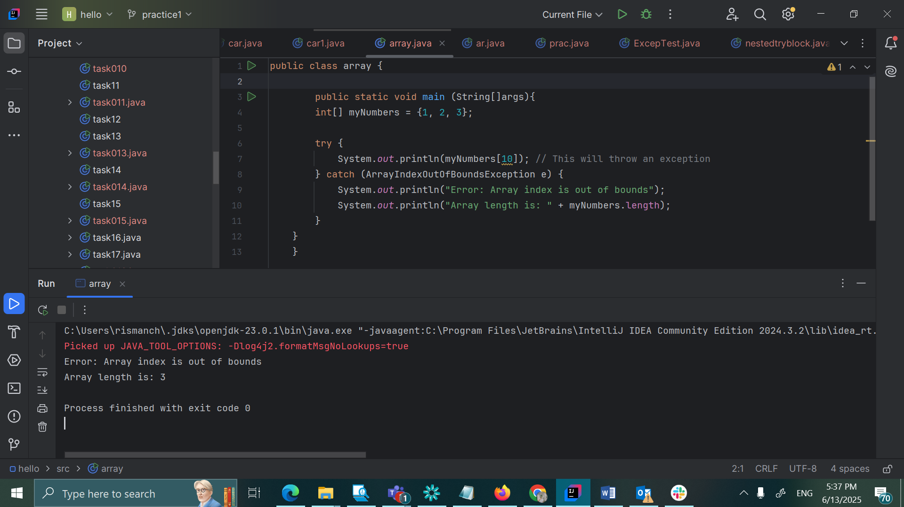

Task 2

